**YT video watched -** <https://www.youtube.com/watch?v=Y1lP07CFP0Y>

**Constructor** is used to initialize the object which are created gradually.

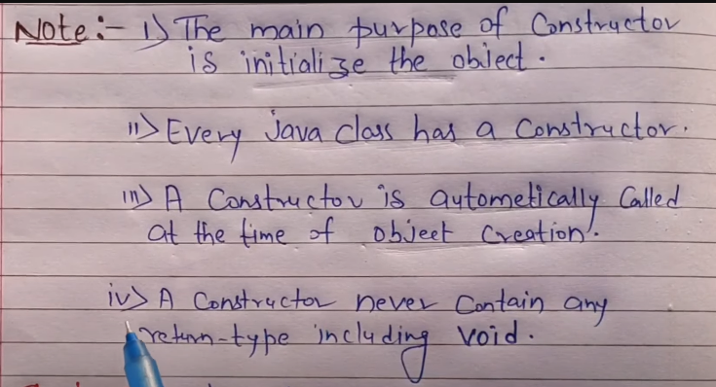

**They are of 3 types.**

**Refer below link:**

<https://www.geeksforgeeks.org/constructors-in-java/>